**Abhiram Basa**

**Assessment 6 of Data Engineering - 09/12/23 .**

Today we discussed about

* Database Basics & Schema.
* Sub-Totals.
* Stored Procedure.
* Analytical Functions - over().
* Common Table Expressions (CTE) .
* Group By Extensions - GROUP BY ROLLUP, GROUPING FUNCTIONS.
* SUB Queries.
* Correlation Sub queries exists.

**Database Basics & Schema**

**Database :** Database is used to store and manipulate the data.

**Schema:** It is the logical representation of data.

Database schema is divided into 3 types

1. Physical level schema
2. Logical level schema
3. View level schema

**Physical level schema:** Designing the database at physical level is known as **Physical level schema.**

**Logical level schema :** The logic that we apply on the data known as **Logical level schema.**

Ex: select * from students where marks > 60.

**View level schema :** The output that you will see after using queries known as **view level schema**.

Ex: It shows the output of above logic used.

Schema are divided into 6 types

1. Flat Model.
2. Hierarchical Model.
3. Network Model.
4. Relational Model.
5. Star Model.
6. Snowflake Model.

**Flat Model :**

* In this model, the data is stored in 2 D array model.
* It can be understood as a single spreadsheet or a database table with no relations.
* This schema design is most suitable for small applications that don't contain complex data.

**Hierarchical Model :**

* The Hierarchical model design contains a tree-like structure.
* It has one-to-many relationship.

**Network Model :**

* It is same as Hierarchical model and it contains many to many relations.

**Relational Model :**

* The relational models are used for the relational database, which stores data as relations of the table.
* RDBMS uses this schema.

**Star Model :**

* It contains facts table and description tables.
* Facts table contains the main attributes and the description tables contains the facts table description.

For example,

Clerk

Accountant

Officer

Manager

CEO

Emp id

Emp name

emp department

Emp address

Department

Dimension Table

Facts Table

**Snowflake Model :**

It contains facts table , dimension tables contains sub dimension tables.

Product_id

Product_name

Product_Prize

User_id

First_name

Address

email

Order Table

Order_id

user

Product_ordered

Product Table

Users Table

**Sub Totals :**

Sub total can be calculated using

* group by roll up
* Grouping

**GROUP BY:**

**group by roll up - used to calculate sub totals**

* It is giving sum of sales of each year as total sum , null is the grand total.

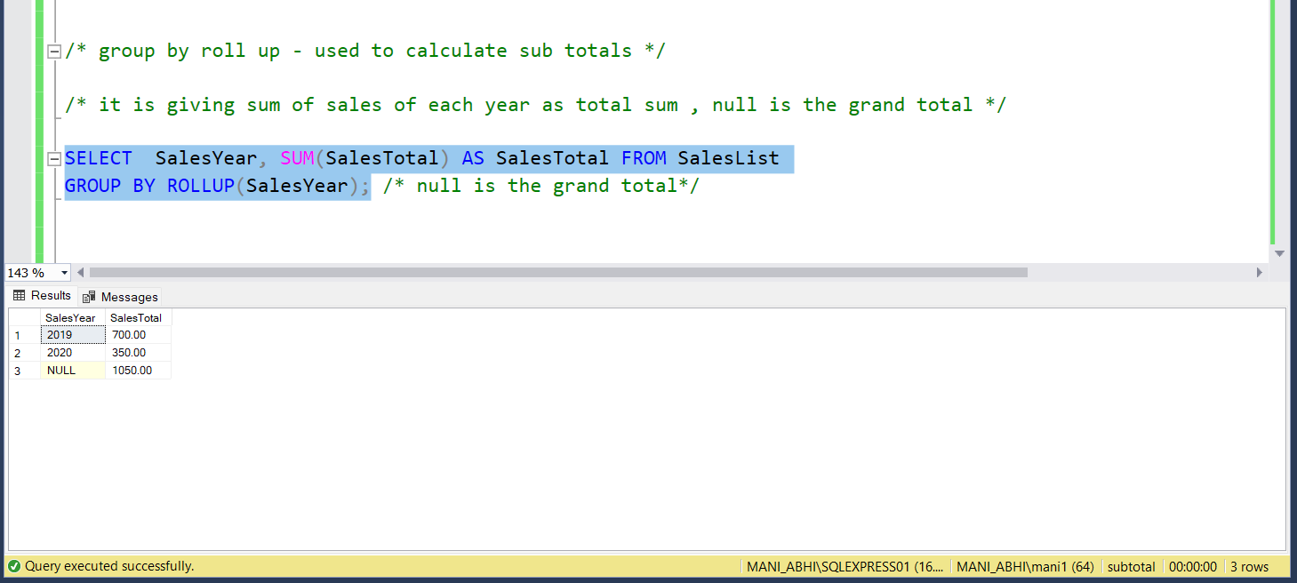

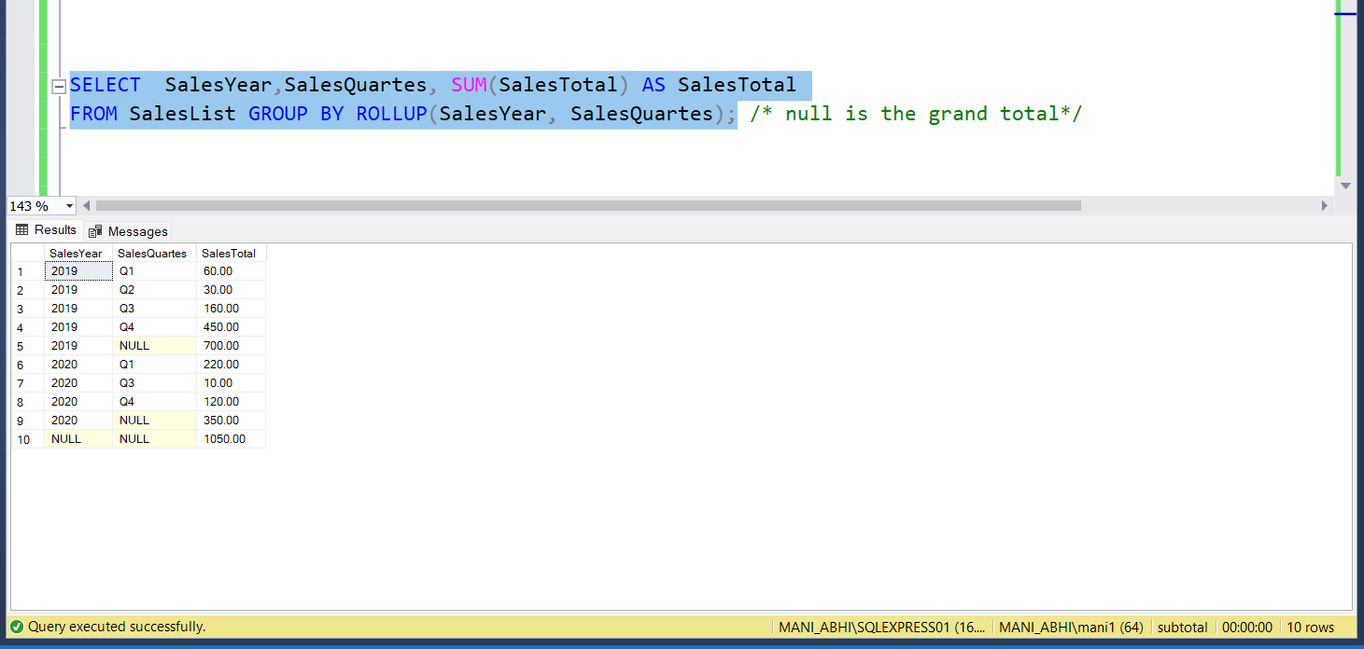

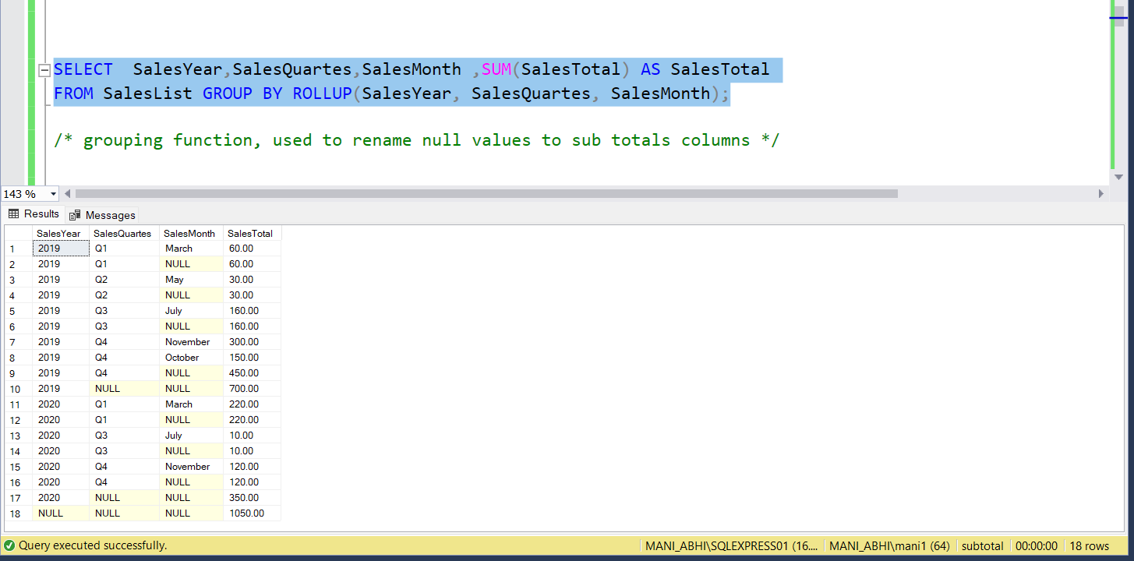

* **grouping function, to calculate sub totals**

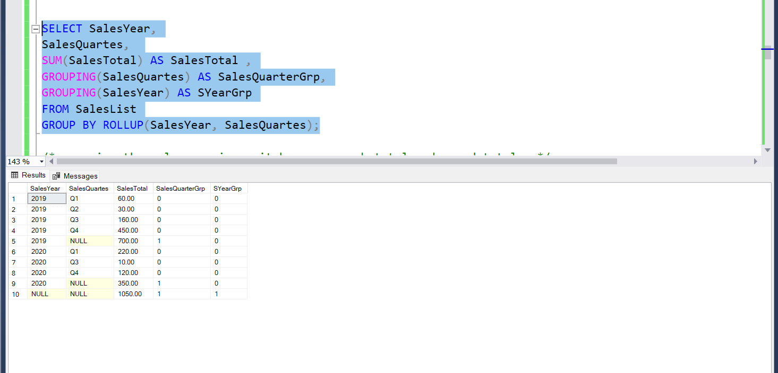

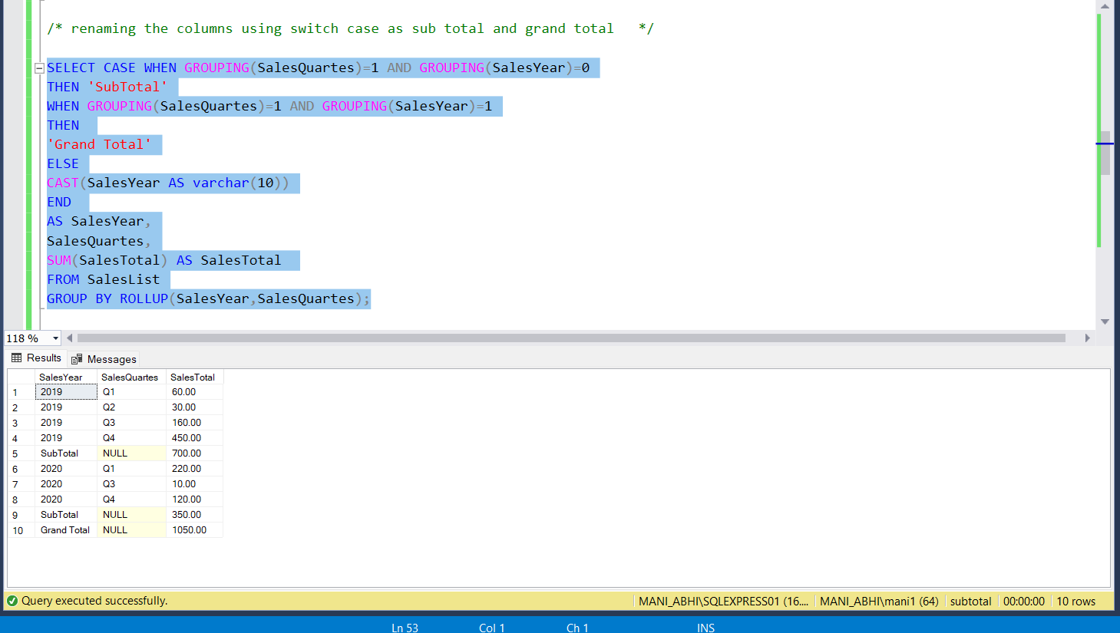

**calculating subtotal for one column using row number() and newid()**

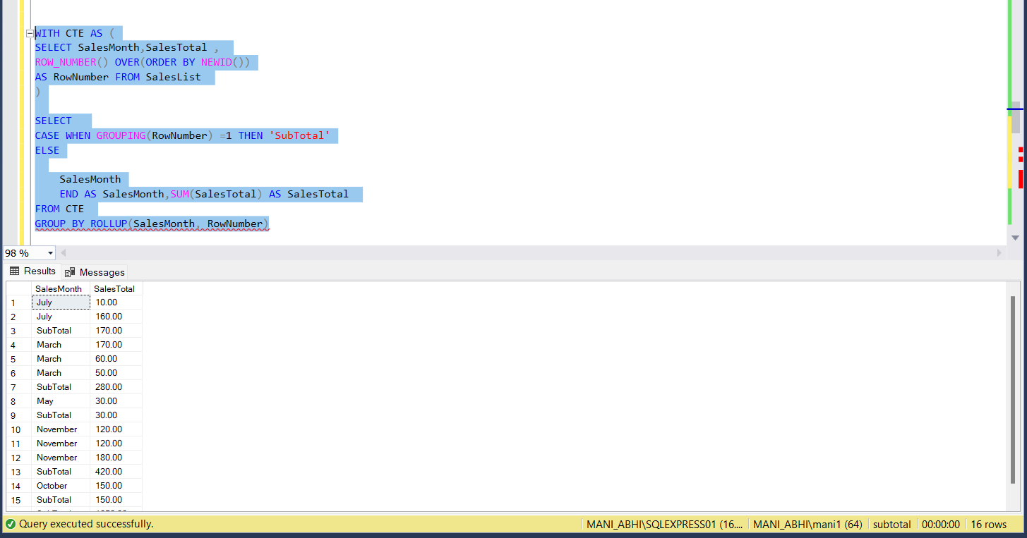

**Common Table Expressions (CTE)**

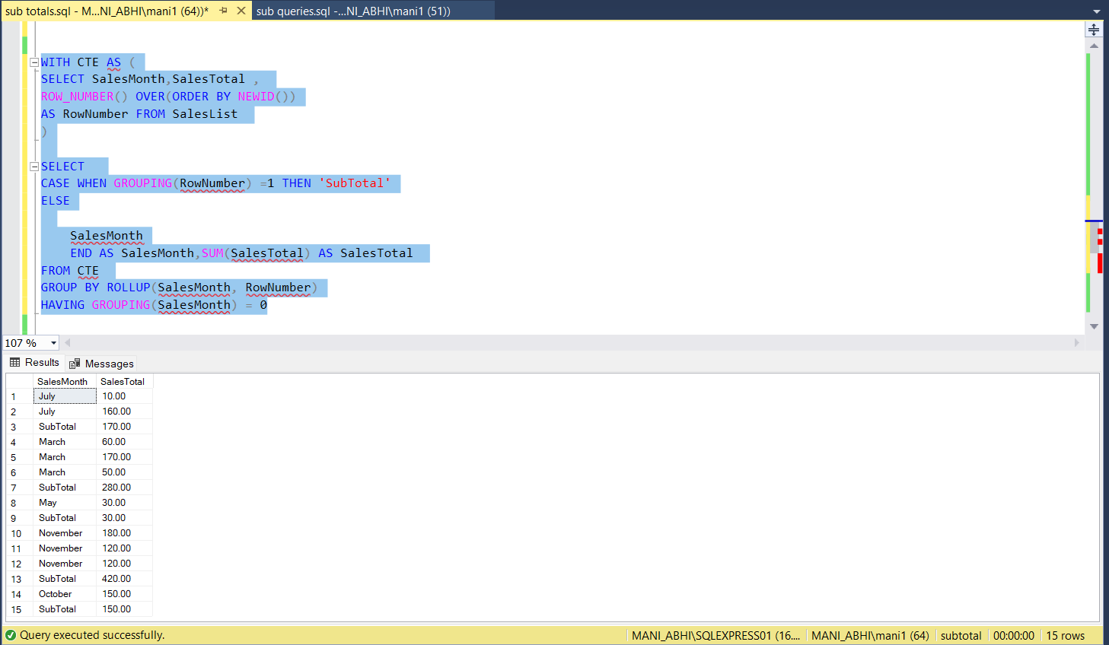

**Cast() :**

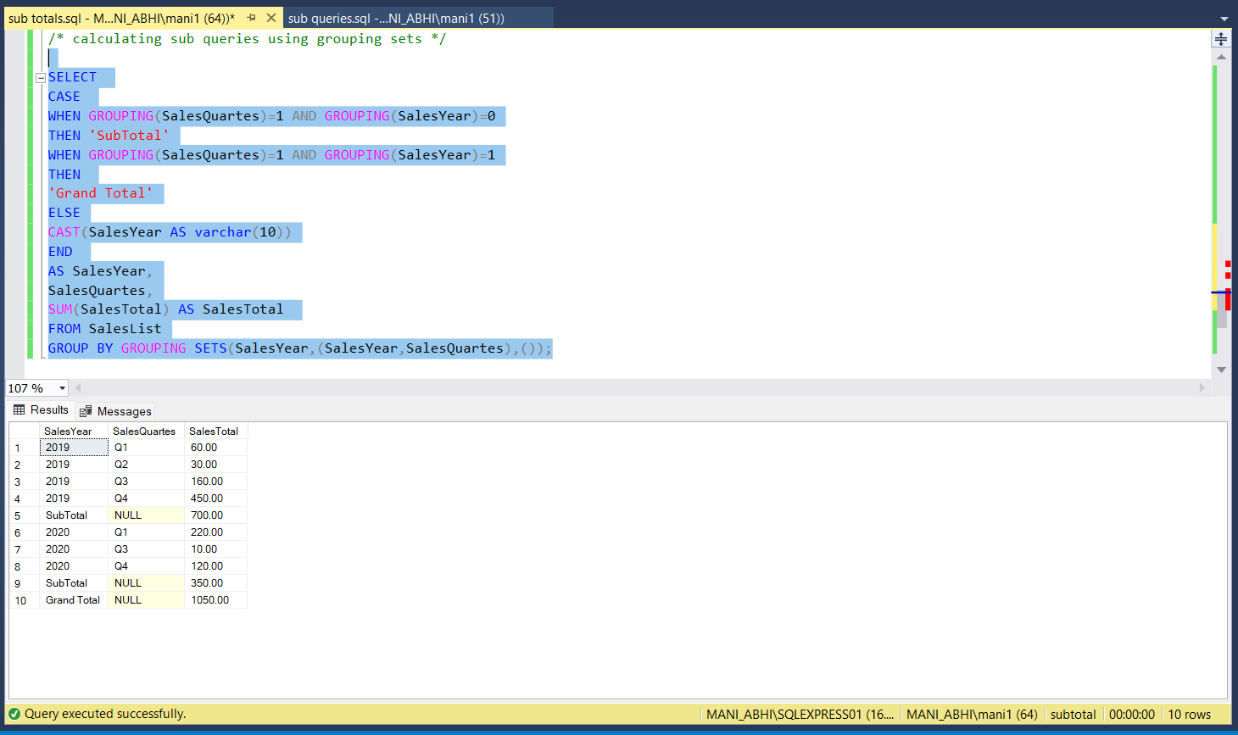

**Stored Procedures :**

**Stored procedure with single values**

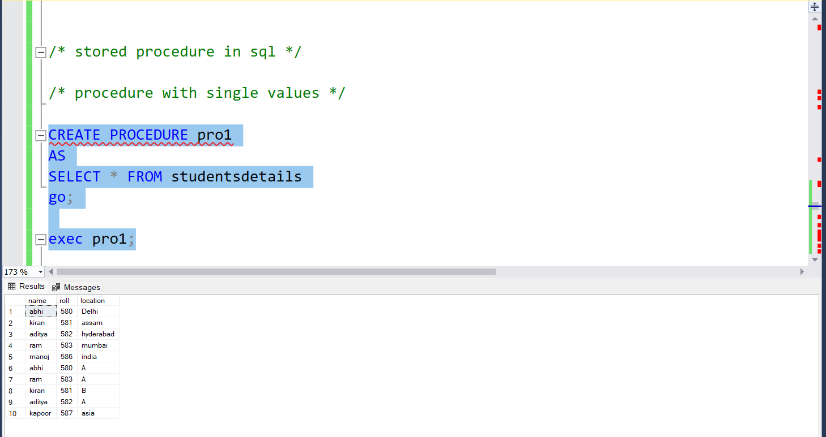

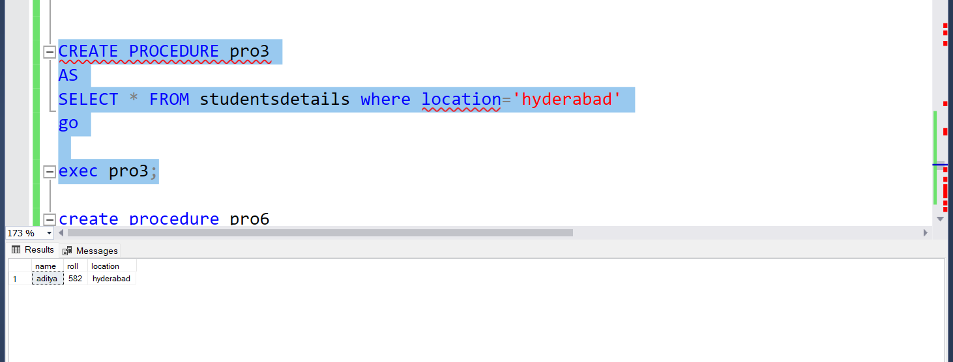

**Stored procedure with single variables**

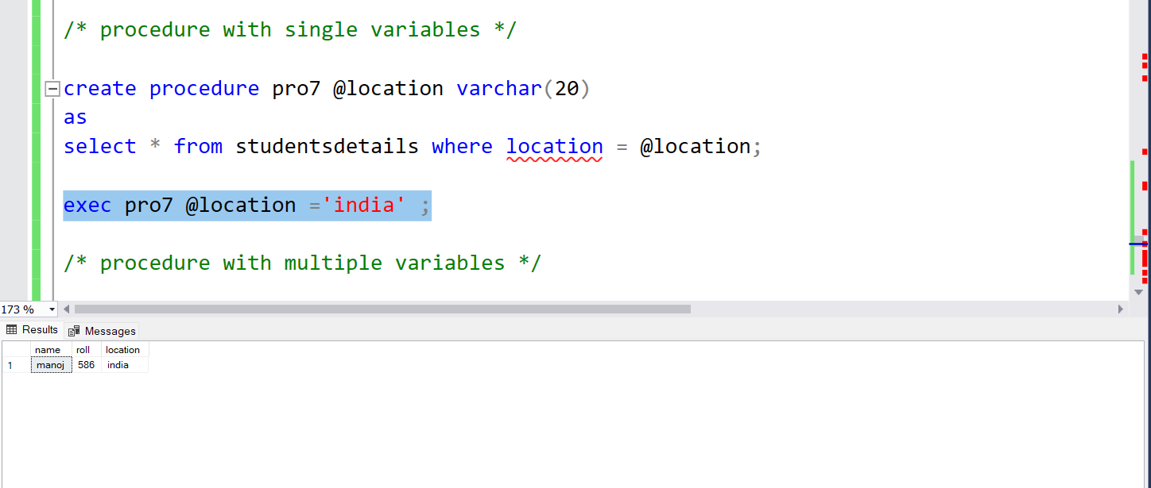

**Stored procedure with multiple variables**

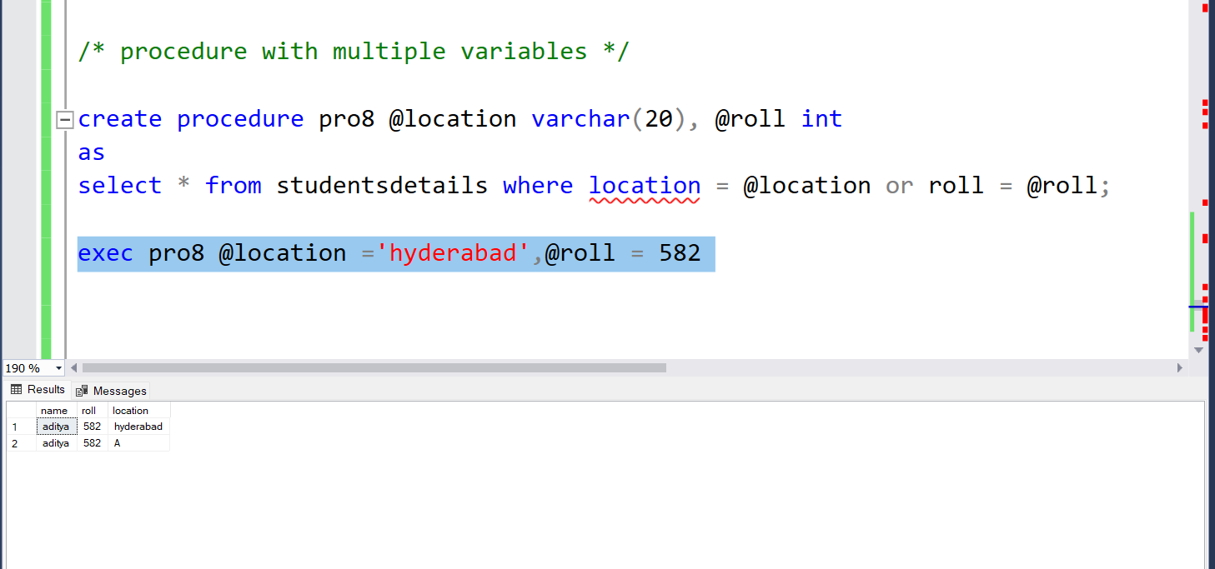

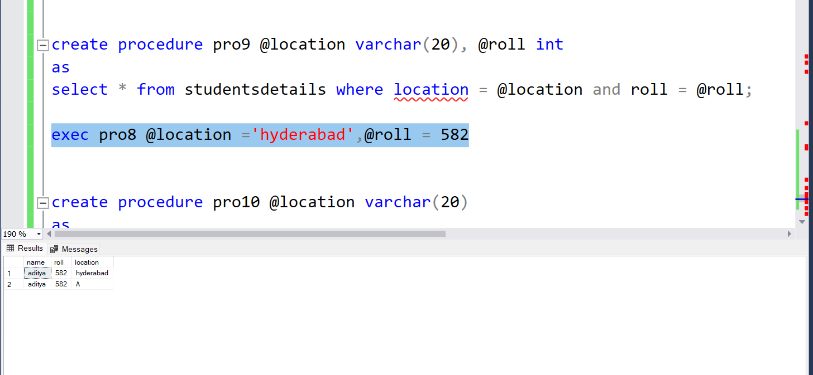

**Correlated Queries :**

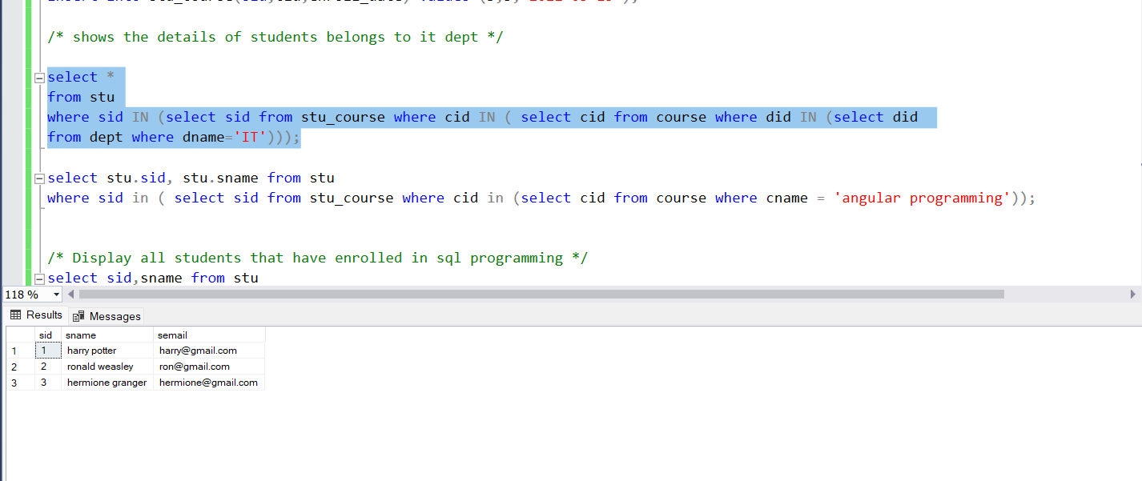

**Display all students that have enrolled in sql programming**

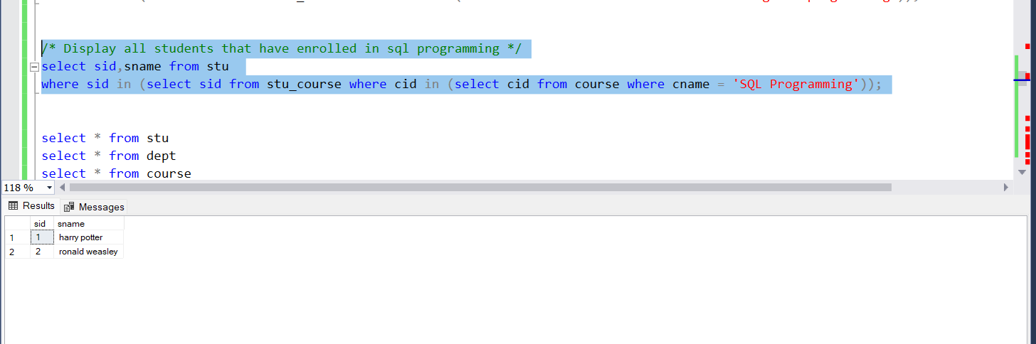

**EXISTS :**

